**1.** **Create a table with a single integer value and populate it with numbers from 0 to 9.**

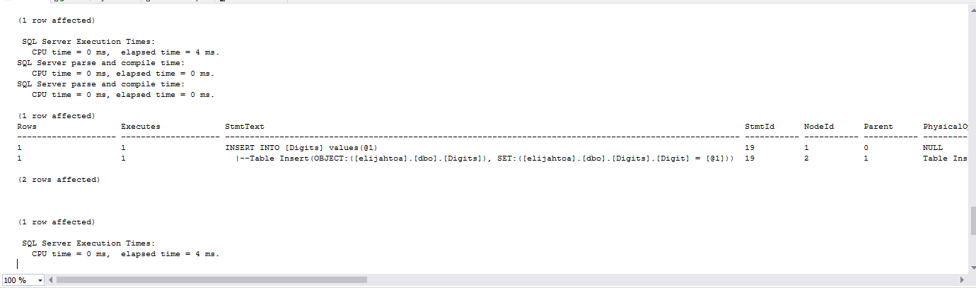

**2.** **Use a CROSS JOIN on the digits table to make a list of elements from 0 to 100.**



**3.** **Use a CROSS JOIN on the digits table to make a list of elements from 0 to 1000.**

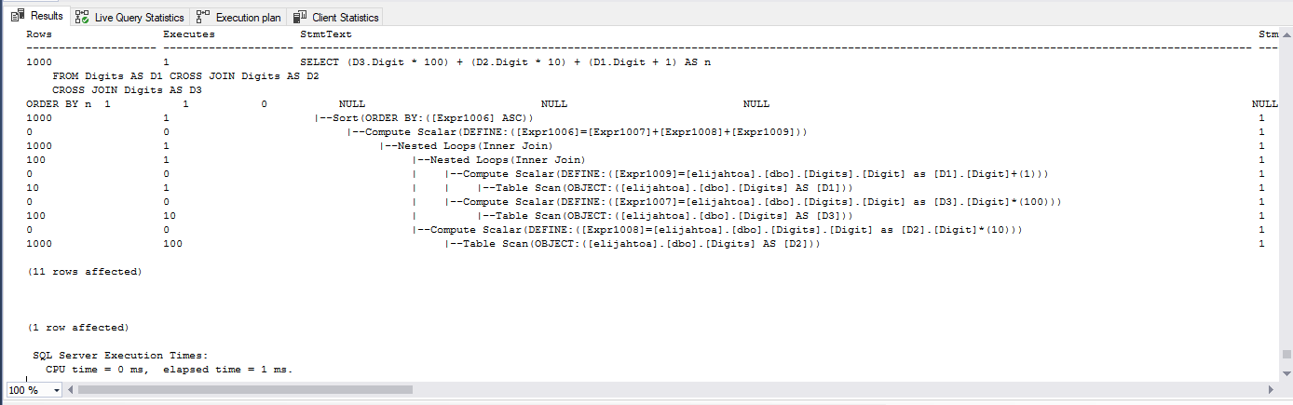

**4.**  **Run the following code and note that it builds a list of numbers from 0 to 9.**

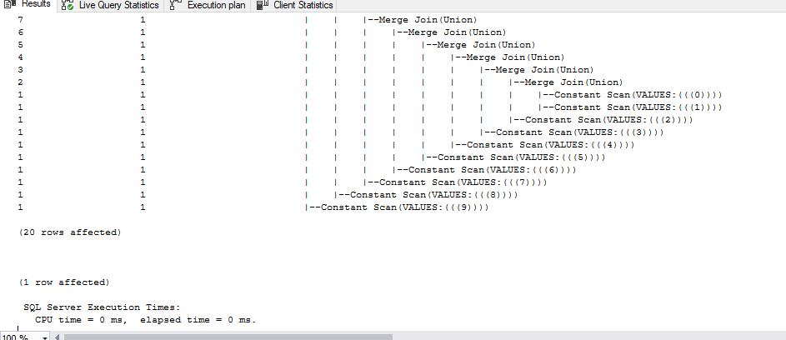

**5.** **Create a table called "PearlJam" that has a single integer attribute. Populate the table with numbers from 1 to 1 million inclusive. If the table exists, drop it and create and populate it again.**

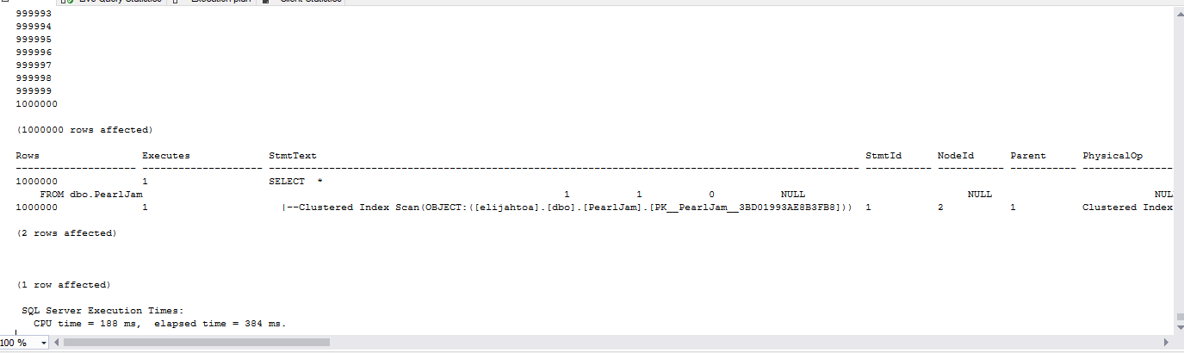

**6. Create a function called "VanHalen" that returns a single attribute of type integer. Display numbers 1 to 1 million inclusive. If the functiontable exists, drop it and create and run it again.**

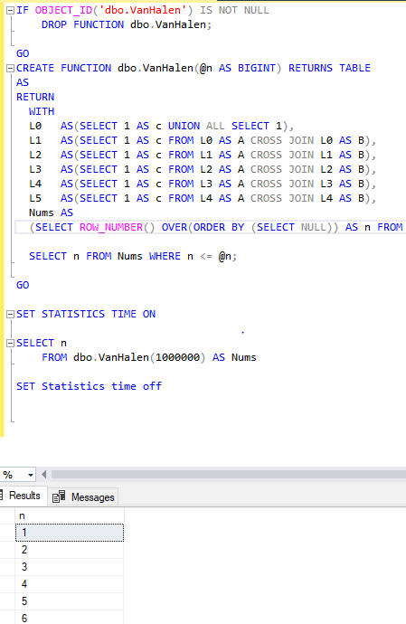

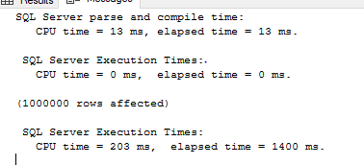

**7. Create a table called "AeroSmith" that has a single integer attribute. Populate the table with numbers from 1 to 1 million inclusive. If the table exists, drop it and create and populate it again. Show statistics for execution times**

AeroSmith crashed mySQL...

**8. Create a function called "BlueOysterCult" that returns a single attribute of type integer. Display numbers 1 to 1 million inclusive. If the function exists, drop it, create, and run it again.**

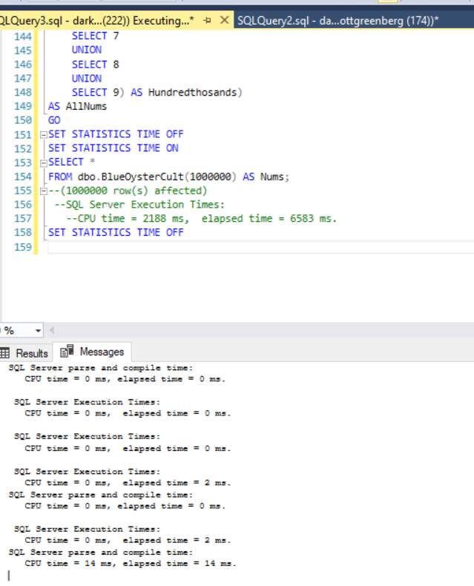

**9. Create a routine that populates a table from 1 to 1 million and call it GunsNRoses. If the table exists, drop it and create and run it again.**

